Ethnicity vs. Perceived Age: Are the Stereotypes True?

# Summary

The ethnicity of a person tends to affect our perception of how old they are; the various stereotypes we hear often reflect this. To investigate the truth behind these stereotypes, we have performed analysis on a data set containing the error in the guesses of ten individuals’ ages (the individuals were of varying ethnicities and ages). Our main conclusion is that the perception of Asian people “aging slower” than white people holds true.

# 1. Introduction

Intuitively, we know that people of different races appear to age differently. Those of African and Asian descent are stereotyped as aging more slowly, and jokes about those of European descent “aging like milk” can commonly be heard coming from people of other ethnicities. But do these perceptions hold true under rigorous statistical testing?

The data set we will analyse to investigate this was created by having a lecture hall full of students at a university guess the ages of ten individuals of varying ethnicities. These ethnicities were White (European descent), Black (African descent), Asian (East Asian descent), and Indian (South Asian descent). Additionally, the students were divided into fifty-five groups of two to three students each, and each group made a single collective guess for each of the ten individuals.

We will investigate if there are significant differences between the guessing errors for the different ethnicities represented in the data set; first, by inspecting the summary statistics for each group, and then by doing some graphical analysis.

# 2. Data inspection

We first load the data set into R as the object guesses, and inspect the first few rows:



Table 1

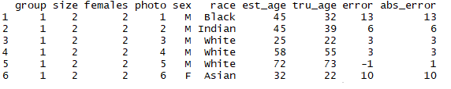

As we can see, guesses has ten columns: group is the group number (1-5); size is the size of the group (2-3); females is the number of females in that group; photo is the photo number of the individual whose age is to be guessed; sex is the gender of that individual; race is the race of that individual; est_age is the age that the group guessed for that individual; tru_age is the true age of that individual; error is the difference between estimated age and the true age, and abs_error is the absolute value of the error.

We now present summaries of the columns of guesses, excluding group and photo; as each group appears ten times in its column and each photo appears 55 times in its column. Thus, those columns require no additional interpretation.



Table 2

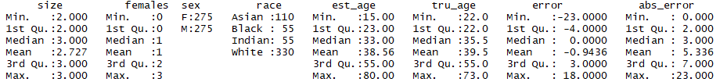

As discussed in the Introduction, the sizes of the groups range between 2 and 3. The average group had only 1 female, however some groups had no females and there were some groups comprised of all females.

The genders of the individuals whose ages are being guessed are equally split. Additionally, there is a higher proportion of Whites represented in the data set, followed by Asians, then lastly Indians and Blacks. The estimated ages of the individuals range from 15 to 80 with a mean of 38.56, and the true ages of the individuals range from 22 to 73 with a mean of 39.5.

The errors range from -23 and 18 with a median of 0 and a mean close to 0; this suggests that the distribution of the errors is roughly symmetric around 0. The absolute errors range from 0 to 23, with a median of 3 with a mean of 5.34, which implies that the distribution of the absolute errors is right-skewed. This also suggests that the more wrong a guess is, the lesser the likelihood of such a guess happening. The histograms of the errors (left) and the absolute errors (right) confirm this. There do not appear to be any outliers.

Figure 1

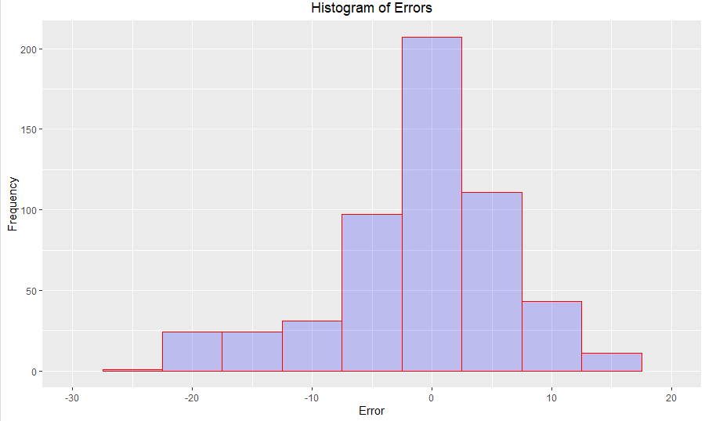

Figure 2

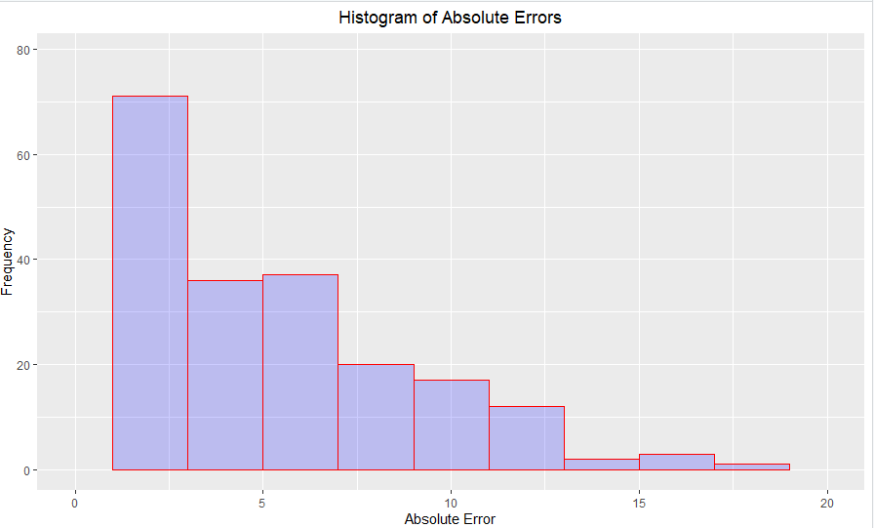

# 3. Data Analysis

# 3.1. Summary Statistics

We will start our analysis by getting the mean and variance of the errors by certain columns of guesses. We begin by considering tru_age.

Table 3



Table 4



There appears to be no discernible trend in the values of the means and variances of the error as the people being guessed get younger or older. Next, we consider the means by sex (variances by sex gives an error in R):

Table 5



This means that, on average, the women in the data set were guessed as being younger than the men. This could perhaps be due to socialisation; as in Western countries, it is considered quite rude to guess that a woman is older.

As discussed in the introduction, our goal is to ascertain whether there are significant differences in the guessing errors for the different ethnicities represented in the data set. To this end, we get the mean and variance of the guessing errors for each of the four races represented in the data set:

Table 6

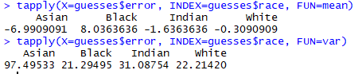

As we should expect, the mean guessing error for the white people represented in the data set is close to zero. This could be explained by the fact that the majority of the students that were taking part in the experiment where white; thus, they would have more experience guessing the ages of other white people.

The mean guessing error for the Asians represented in the data set is -6.991. This is consistent with the commonly held stereotype that Asian people “age slower” than white people.

Surprisingly, the mean guessing error for the Black people in the data set is 8.036, which means that on average, Black people were perceived to be older than their true age. One possible explanation for this is that there was only one Black representative in the photos. As variance is inversely correlated with sample size, having additional Black people in the photos would give a more accurate picture of how their ages were perceived.

The mean guessing error of the Indians represented in the data set is -1.636. There aren’t many popular stereotypes about Indian aging, so the Indians aren’t of interest for the purposes of our analysis.

The variances of the guessing errors for each of the races are quite high; however, this is because there are only ten individuals in total whose ages are being guessed, and, again, a smaller sample size is correlated with a high variance. If the experiment were to be conducted again, increasing the number of individuals whose ages were being guessed, and ensuring an equal distribution of the races represented would give more accurate results.

# 3.2. Graphical Analysis

We now perform some graphical analysis of the data by representing the distribution of errors by each column that we analysed above, with boxplots. This should provide some additional insight into the ranges, interquartile ranges, and outliers. We first consider true age:

Figure 3

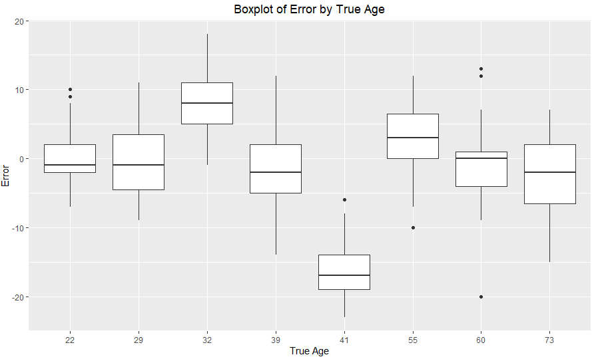

The distributions for each age are mostly symmetrical, with the clear exceptions of ages 22 and 60. The median error for the 22-year-olds was just below zero, but the distribution was positively skewed, meaning that a lot of the students guessed them closed to correct or slightly older. The median error for the 60-year-old was just about zero, however the distribution was negatively skewed, which means that the bottom half of the student groups guessed him as younger than he actually was. Next, we consider sex:

Figure 4

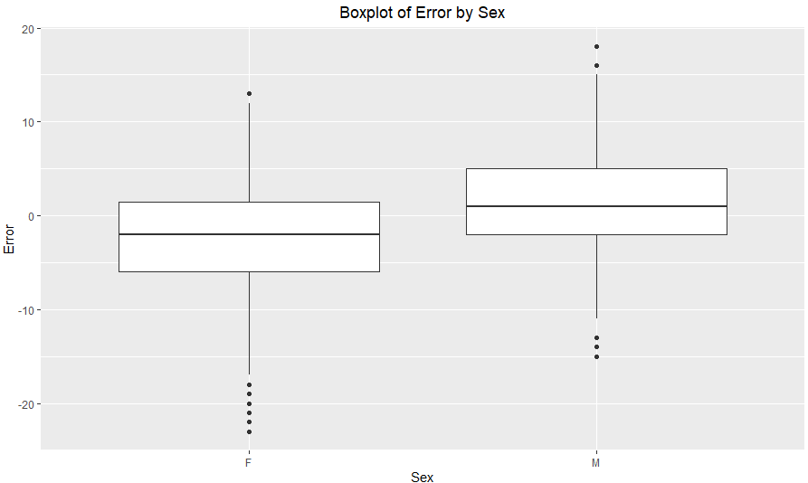

Our finding in the above section that the women in the data set tended to be guessed as younger than the men is true; however, the magnitude of this difference is lessened when we consider the median instead of the mean, and the sheer amount of outliers that guessed the females as younger. Lastly, to achieve the objective we described in the Introduction, we consider race:

Figure 5

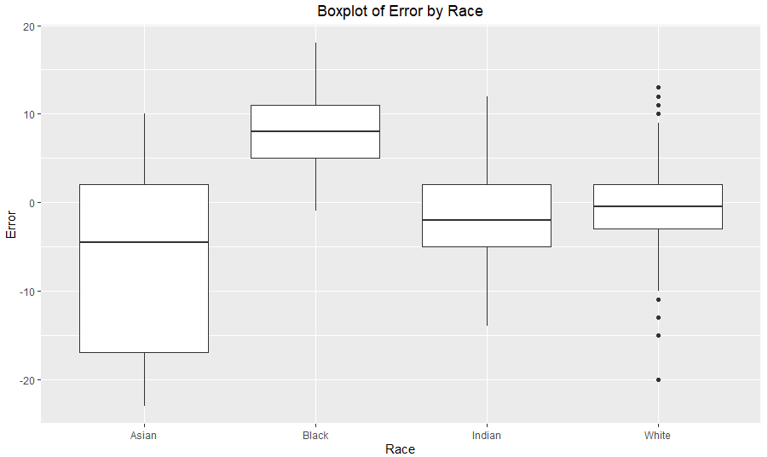

The boxplots of errors for the one Black person and the Indians represented in the data set don’t reveal much of note beyond what we already know about the distributions. Both distributions are roughly symmetrical, with the Indians’ distribution being slightly positively skewed, and the Indians have the second largest range (again, excluding outliers). This is consistent with our above finding in Section 3.2 that the Indians’ errors had the second largest variance.

The Asians have the largest range of errors by far (excluding outliers), which is consistent with our finding in Section 3.1 that they had the highest variance for guessing error. The distribution is negatively skewed, with most of the guessing errors lying to below the median of about -5.

The distribution of errors for the Whites is also roughly symmetrical around the median of just about zero; however, there were several outliers both on the positive and negative sides. This indicates that there were just a few guesses that were wildly incorrect. There is a possible explanation for this; there was a small minority of ethnic minorities among the students that participated in the experiment. Perhaps having less interaction with white people than most white students may have caused some of them to guess more incorrectly.

Since the majority of the Asians’ distribution lies below 0, and the Whites’ distribution is centered around 0, there is strong evidence that the perception of Asians “aging slower” holds true.

# 4. Hypothesis Testing

We now proceed to rigorously test if the perception of Asians “aging slower” is likely to hold true for the entire population of Whites and Asians. Specifically, we’d like to compare the mean guessing errors.

Since the sample sizes are large (110 guesses for the Asians, 330 for the Whites), we can assume normality for the sampling distribution by the Central Limit Theorem. Also, since the Asian and White samples are independent of one another; and since we don’t know the population standard deviations, we will use a two-sample t-test.

We denote the Asians’ mean guessing error as µA and Whites’ mean guessing error as µW. We wish to compare the null hypothesis:

* H0: µA = µW

With the alternative hypothesis:

* H0: µA < µW

We run the hypothesis test in R and get the following results:

Table 7

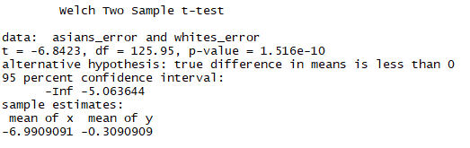

As our p-value is extremely small, we can reject the null hypothesis and accept the alternative hypothesis; that the mean guessing error for Asians is less than the same for Whites.

# 5. Conclusion

In conclusion, we have performed exploratory analysis, numerical analysis, data visualisation, and hypothesis testing on a dataset containing the guessing errors of the ages of ten individuals of varying races; guessed by British university students during a lecture. The evidence strongly suggests that the stereotype of Asians “aging better” holds true; and that the equivalent stereotype for Black people does not hold true. However, the lack of representation of Black people in the data set (there was only one) is skewing the results. Data collection could have been improved by ensuring that there was a more even balance of races represented in the data set.